Local Detectors and Descriptors

The purpose of a local invariant feature is to provide a representation that allows to efficiently match local structures between images. To meet this end, the feature extractors must fulfill two important criteria.

- The feature extraction must be repeatable and precise (so that similar features are extracted on similar images)
- the features should be distinctive

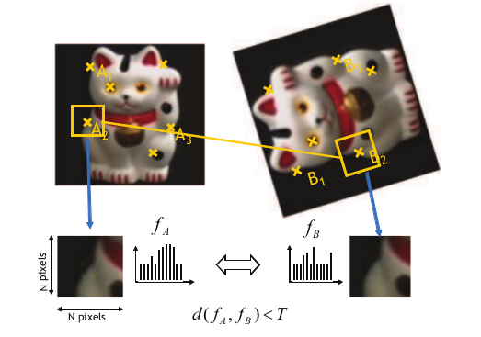
On this image, we take each keypoint we found and define a surrounding region in a scale-invariant manner. We extract and normalize the region content and compute a local descriptor for each region.

Finally the features need to be defined in such a way that they cover the whole image, hence the use of a feature extraction pipeline:

- find set of distinctive keypoints
- define scale invariant region around them
- extract and normalize region content
- compute descriptor from the normalized region
- (match local descriptors)

Keypoint localization

The Hessian Detector

Searches the image for locations that exhibit strong derivatives (aka strong movement) in two orthogonal directions. It is based on the second derivative matrix (hessian)
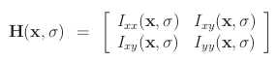
The detector computes the determinant and trace of the hessian. The Harris detector defines keypoints to be “points that have locally maximal self matching precision under translational least squares template matching” (region around points that have two large eigenvalues).

Scale invariant region detection

While shown to be robust to image plane rotations, illumination changes and noise, the locations returned by Harris are sensitive to scale changes (because we are computing the derivatives based on gaussians computed at a certain base scale sigma)

Automatic scale Selection

Given a keypoint in each image of an image pair, we want to determine whether the surrounding image neighborhoods contain the same structure (with different scale).

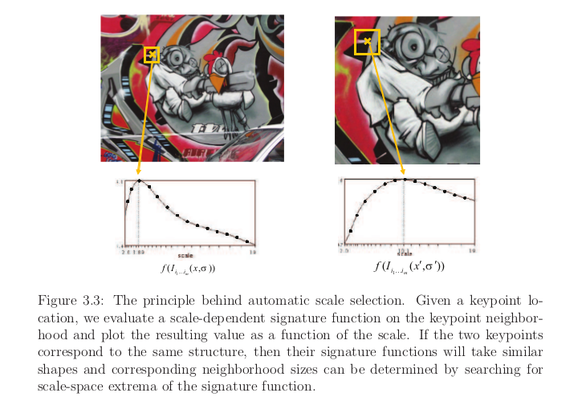
The bigger the signature function value, the bigger the neighborhood. Guassian Kernels are the only type of function that give satisfying results

Laplacian of Gaussian (LoG) Detector

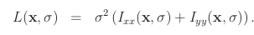
This filter mask corresponds to a circular center surround structure, wuth positive weights in the center region and negative weights in the surrounding ring structure

Harris Laplacian Detector

It first builds two separate scale spaces for the Harris function and the laplacian, it then uses the Harris function to localize candidate points on each scale level and selects those points for which the Laplacian simultaneously attains an extremum over scales

